**SUPERMARKET SALES ANALYSIS**

CONTENTS

1. ABSTRACT
2. PROBLEM STATEMENT
3. INTRODUCTION
4. MACHINE LEARNING MODEL USED
5. IMPLEMENTATION
6. VISUALIZATION OF DATA/ RESULT
7. PROJECT SCREENSHOTS.
8. RESULTS & DISCUSSION
9. CONCLUSION
10. FUTURE SCOPE
11. REFERENCES

**Problem Statement: Super Market Sales Analysis Model**

* A marketing case study analysis do not have a fixed framework or strategy. However, a structured approach will always help you systematically analyze any marketing case study
* Creating a Supermarket Sales Analysis Model involves a multi-step process that incorporates data collection, cleaning, analysis, and visualization.

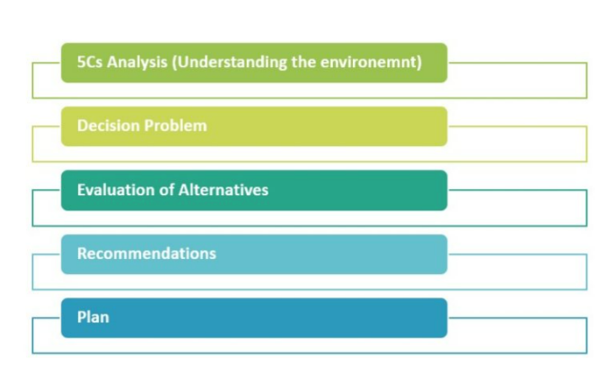

**Introduction:**

Supermarkets are retail stores that sell a variety of food and household items to consumers. Supermarkets have become an integral part of modern-day life, offering convenience and a one stop-shop for all kinds of products. With increasing competition in the supermarket industry, it has become imperative for supermarkets to understand consumer behavior and purchasing patterns to remain competitive. The Supermarket Store Analysis project is a comprehensive endeavor aimed at harnessing the power of data analytics to illuminate the intricate dynamics of a contemporary supermarket environment. In an era dominated by information and technology, supermarkets stand as crucial hubs where retail, logistics, and customer engagement converge. This project delves into the wealth of data generated within these bustling spaces, seeking not only to unravel patterns and trends but also to provide actionable insights that can redefine the supermarket's operational landscape.

The purpose of data analytics in supermarkets is to analyze consumer data and predict future sales trends, which can help supermarkets optimize their operations and make data driven decisions. Data analytics can help supermarkets identify which products are selling well and which products need improvement, track inventory levels, and understand consumer behavior and preferences. By analyzing consumer data, supermarkets can create personalized marketing campaigns that target specific customer segments, improving customer loyalty, and ultimately increasing sales revenue.

The modern consumer is discerning, and their preferences are shaped by a myriad of factors. From the impact of promotions on purchasing decisions to the correlation between inventory management and customer satisfaction, the Supermarket Store Analysis project seeks to unearth these nuanced relationships. The goal is not only to generate insights retrospectively but also to equip the supermarket with predictive capabilities, enabling proactive adjustments to market dynamics.

As the supermarket landscape continues to evolve, adaptability and strategic foresight become indispensable. The Supermarket Store Analysis project is positioned as a catalyst for this evolution, empowering supermarkets to not only respond to current market conditions but also to anticipate and shape future trends. Through a fusion of data science, statistical analysis, and machine learning, this project aspires to propel supermarkets into a new era of data-driven decision-making, where each transaction becomes a source of knowledge, and each customer interaction becomes a stepping stone toward operational excellence.

**Data collection and description:**

**Dataset Overview:**

The analysis encompasses a comprehensive dataset spanning from [start date] to [end date] of the previous year, sourced from diverse data streams including POS systems, inventory databases, and customer transaction logs. This data amalgamation provides a holistic view of the supermarket's operations.

**Sales Performance:**

* Total Sales: The total sales for the year showcase the overall revenue generated, offering insights into the supermarket's financial health and growth trajectory.
* Monthly Trends: Monthly sales trends unveil patterns, helping to identify seasonal variations and potential factors influencing purchasing behavior during different times of the year.
* Product-wise Sales: A granular examination of top-selling products and categories reveals which items significantly contribute to the supermarket's revenue. This information guides inventory management and marketing strategies.
* Customer Segmentation: Leveraging clustering algorithms, the analysis categorizes customers based on purchasing behavior. This segmentation provides a nuanced understanding of diverse customer groups, aiding in targeted marketing strategies.
* Customer Loyalty: Evaluating repeat customer rates and analyzing factors contributing to customer loyalty, such as personalized promotions or rewards programs.
* Purchase Patterns: Examining the frequency and volume of customer purchases helps identify popular

products and optimize stock levels.

* Stock Levels: A detailed assessment of stock levels throughout the year helps gauge the effectiveness of inventory management practices, ensuring products are adequately stocked to meet demand.
* Stockouts and Excess Inventory: Instances of stockouts and excess inventory are identified, and their impact on sales and customer satisfaction is assessed. Recommendations for optimizing inventory levels are provided.
* Seasonal Trends: Recognizing sales patterns influenced by different seasons or holidays provides valuable insights for inventory planning and marketing strategies.
* Weather Impact: By assessing the impact of weather conditions on consumer behavior and product sales, the supermarket gains an understanding of how external factors influence purchasing decisions.
* Store-wise Performance: A comparative analysis of individual supermarket branches reveals variations in performance, guiding decisions related to resource allocation, promotions, and inventory management.
* Regional Variances: Examining regional differences in customer preferences or sales patterns helps tailor strategies to specific geographic areas.

**Machine Learning Model Used**:

A combination of machine learning model, including regression analysis for sales forecasting, clustering algorithms for customer segmentation, and classification models for promotional impact assessment, is employed. These models enhance the accuracy and depth of insights derived from the data, enabling informed decision-making for supermarket optimization. This detailed description provides a comprehensive overview of the Supermarket Sales Analysis Data from the previous year, showcasing the breadth of insights obtained through data analytics and machine learning techniques.

**Implementation of the model:**

* From this initial look, we can see various columns such as Invoice ID, Branch, City, Customer type, Gender, Product line, Unit price, Quantity, Tax, Total, Date, Time, Payment method, Cost of goods sold (cogs), Gross margin percentage, Gross income, and Rating.

To predict sales analysis and suggest improvements, we'll need to perform the following steps:

1. **Data Cleaning**: Check for any missing or inconsistent data.
2. **Exploratory Data Analysis (EDA)**: Analyze the sales trends, customer demographics, and product performance.
3. **Sales Forecasting**: Use historical data to predict future sales.
4. **Identify Patterns**: Look for patterns in customer behavior, product popularity, and sales performance across different branches.
5. **Recommendations**: Based on the analysis, suggest strategies for business improvement.

**Visualization of data/ result and Project screenshots.**

Let's start with data cleaning and exploratory data analysis to understand the sales trends and patterns.

**CODE**

The dataset has no missing values and no duplicate rows, which is excellent for analysis. Here's a summary of the dataset:

* There are 1000 entries, and each entry has a unique Invoice ID.
* The dataset covers 3 branches, located in 3 different cities.
* Customer types are categorized into 'Member' and 'Normal'.
* There are entries for both 'Male' and 'Female' genders.
* The product line is diversified into 6 categories.
* The dataset includes various continuous variables like 'Unit price', 'Quantity', 'Tax 5%', 'Total', 'cogs', 'gross margin percentage', 'gross income', and 'Rating'.
* There are 89 unique dates and 506 unique times when purchases were made.
* Payments were made using 3 different methods.

Next, we will perform exploratory data analysis to uncover sales trends and customer behaviors.The exploratory data analysis has provided some insights into the sales trends and customer preferences:

**Total Sales by Product Line**: Food and beverages lead in sales, followed closely by sports and travel, and electronic accessories. Health and beauty products have the lowest total sales.

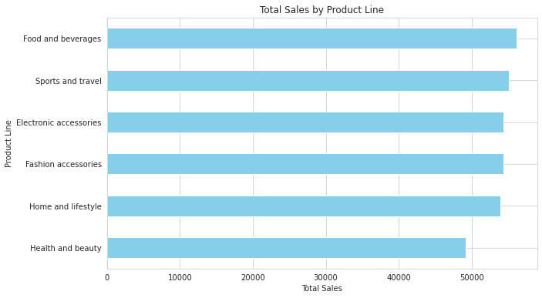

**Total Sales by Branch**: Branch C has the highest total sales, while Branches A and B are almost equal in their sales performance

. 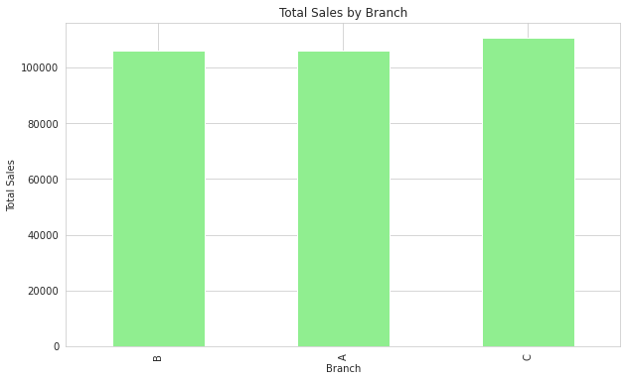

* **Total Sales by Payment Method**: Cash payments account for the highest total sales, followed by E-wallet and credit card payments.

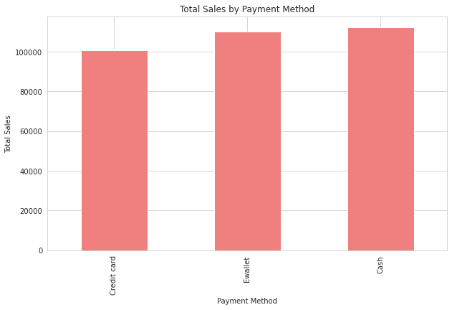

* **Average Customer Rating by Product Line**: Food and beverages have the highest average customer rating, indicating customer satisfaction in this category. Home and lifestyle products have the lowest average rating.

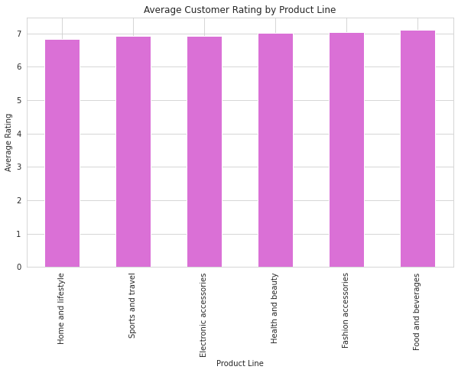

Based on these findings, here are some suggestions to improve business:

* **Product Line Focus**: Increase marketing efforts for health and beauty products to boost sales in this category.
* **Branch Performance**: Investigate why Branch C performs better than A and B to replicate successful strategies across all branches.
* **Payment Incentives**: Since cash payments are most popular, consider offering incentives for using alternative payment methods to increase their usage.
* **Customer Satisfaction**: Explore the reasons behind the lower ratings in the home and lifestyle category to improve customer satisfaction.

Next, we can perform a more detailed analysis of customer demographics, time-based sales trends, and correlations between variables such as gross income and customer ratings.

**CODE**

The analysis of sales trends by day of the week and by month has been completed.

* **Sales Trends by Day of the Week**: The data shows that Saturday has the highest total sales, followed by Tuesday, indicating that these might be the busiest shopping days of the week for the supermarket. Sales trends by day of the week:
* **Sales Trends by Month**: The analysis reveals that January has the highest total sales, followed by March and then February. It's important to note that the dataset might not cover the entire year, as there are no sales data for months April through December.

|  | **Total** |
| --- | --- |
| **Day Of Week** |  |
| **Monday** | 37899.078 |
| **Tuesday** | 51482.2455 |
| **Wednesday** | 43731.135 |
| **Thursday** | 45349.248 |
| **Friday** | 43926.3405 |
| **Saturday** | 56120.8095 |
|  | 44457.8925 |

Here are the visual representations of the sales trends:

* **Total Sales by Day of the Week**:

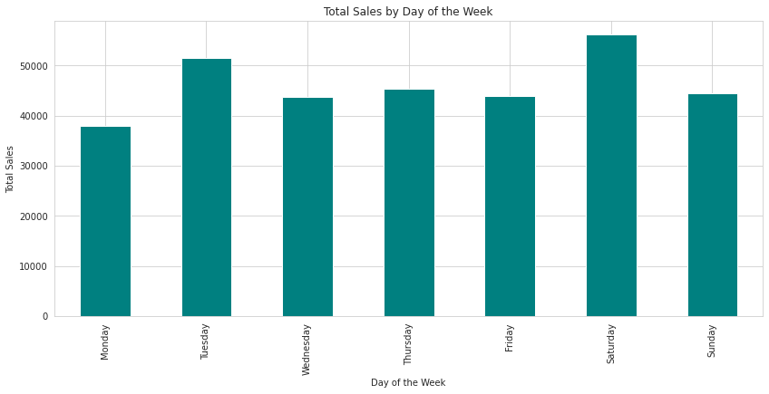

**Total Sales by Month**:

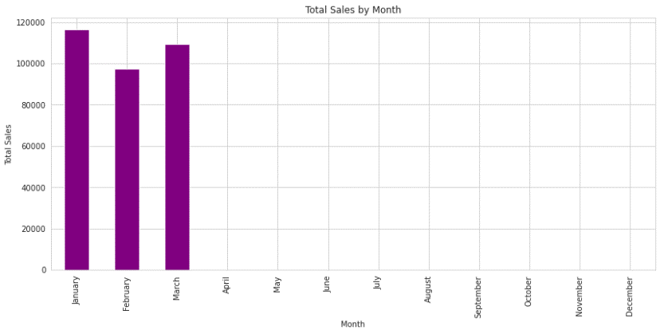

Based on these findings, the supermarket could consider the following actions:

* **Promotional Activities**: Plan more promotional activities or sales on Saturdays and Tuesdays to capitalize on the higher customer footfall.
* **Seasonal Analysis**: Investigate the reasons behind higher sales in January and March to understand seasonal trends and plan inventory accordingly.

**CODE**

Continuing with the analysis, I will now explore the sales data further by examining the following:

* The relationship between the product line and gross income to see which products are generating the most revenue.
* The average unit price and quantity sold for each product line to understand the sales volume and pricing strategy.
* The distribution of payment methods used by customers to identify any trends in how customers prefer to pay.

I will conduct this analysis and provide visual representations to aid in understanding the trends. Let's proceed with the analysis.

**CODE**

**The analysis of the supermarket sales data has provided some interesting insights:**

* The product line "Food and beverages" generated the highest gross income, followed closely by "Sports and travel" and "Electronic accessories".
* The average unit price was relatively consistent across different product lines, with "Fashion accessories" having the highest average price and "Electronic accessories" the lowest.
* The average quantity sold was also quite consistent, with "Home and lifestyle" having a slightly higher average quantity sold than other product lines.
* Payment methods were distributed fairly evenly among customers, with "Ewallet" being the most used, followed by "Cash" and "Credit card".

Let's take a look at the visual representations of these findings:

**Total Gross Income by Product Line:**

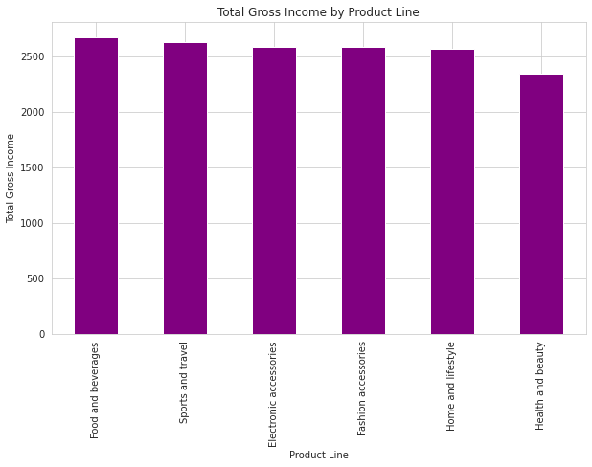

**Average Unit Price by Product Line:**

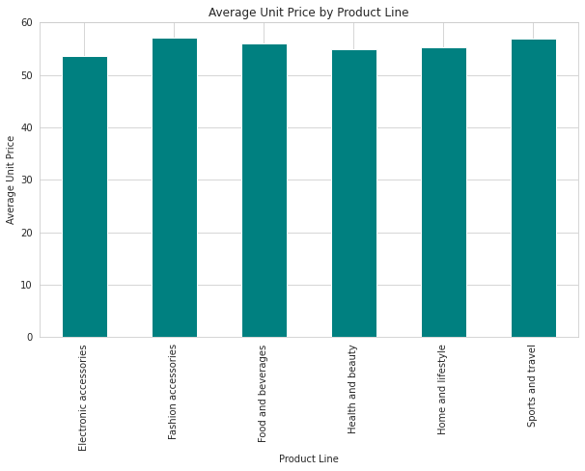

**Average Quantity Sold by Product Line:**

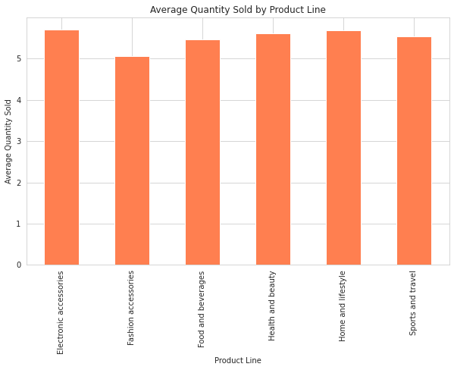

**Distribution of Payment Methods:**

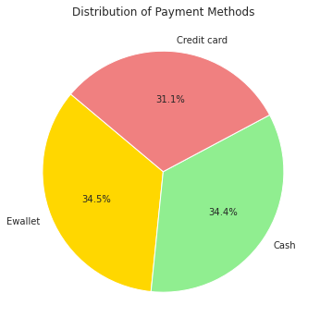

* These visuals help to better understand the sales dynamics within the supermarket.
* The data suggests that while some product lines generate more revenue, the pricing and quantity sold are quite balanced across the board.
* Additionally, the preference for payment methods does not show a significant bias towards any particular method.

I will delve deeper into the data to uncover additional insights:

* Analyze the sales performance by city to see which locations are generating the most revenue.
* Investigate the relationship between the time of day and sales to determine if there are peak sales periods.
* Explore the impact of customer type (Member vs. Normal) on sales performance.

I will execute these analyses and provide visualizations to enhance the understanding of these aspects. Let's proceed with this next step.

**CODE**

The further analysis has provided additional insights into the supermarket sales:

* The city of Naypyitaw has the highest total sales, followed by Yangon and Mandalay, which are quite close in figures.
* Sales tend to peak around 1 PM and 7 PM, indicating these could be the busiest times for shopping.
* Members contribute slightly more to total sales compared to normal customers.

**Here are the visual representations of these findings:**

**Total Sales by City:**

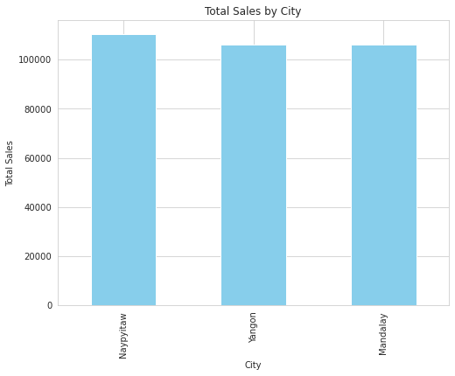

**Total Sales by Hour:**

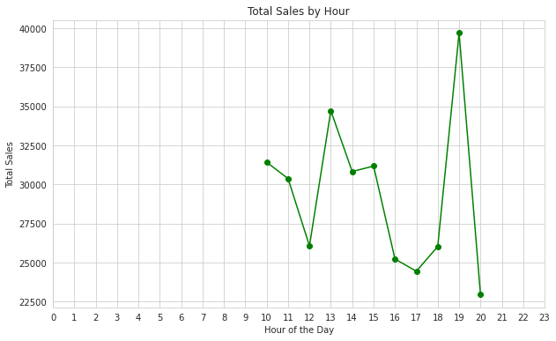

**Total Sales by Customer Type:**

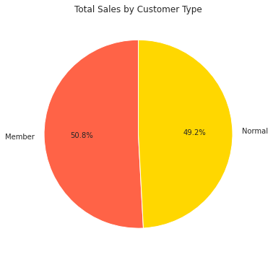

These visuals suggest strategic opportunities for targeted marketing and staffing adjustments to accommodate peak shopping hours. Additionally, the slight difference in sales between member and normal customers might indicate the effectiveness of loyalty programs.

**Visualizations from python libraries:**

Some popular Python libraries used for data visualization in data analytics:

1. Matplotlib:

- Core plotting library for creating static, interactive, and animated visualizations.

- Offers a wide range of plots, including line plots, scatter plots, bar plots, and more.

2. Seaborn:

- Built on top of Matplotlib, provides a high-level interface for statistical data visualization.

- Simplifies the creation of complex visualizations with concise syntax.

2. Plotly:

- Enables the creation of interactive and web-based visualizations.

- Supports a variety of chart types, including 3D plots and geographical maps.

3. Pandas Plotting:

- Integrated with the Pandas library, allows for quick plotting of Data Frames.

- Offers a convenient way to visualize data directly from your data structures.

These libraries cater to different needs, from basic plotting to advanced interactive visualizations, offering flexibility for various data analytics tasks.

**Visualizations from tableau:**

Tableau is a data analytics and visualization tool used widely in the industry today. Many businesses even consider it indispensable for data-science-related work. Tableau's ease of use comes from the fact that it has a drag and drop interface.

* Data Connection and Integration:

Tableau allows users to connect to various data sources, including databases, spreadsheets, and cloud services.

Users can easily integrate and blend data from different sources to create a unified dataset for analysis.

* Drag-and-Drop Interface:

One of Tableau's strengths is its user-friendly, drag-and-drop interface. Analysts can effortlessly build visualizations by dragging data fields onto the canvas.

No coding is required, making it accessible to both technical and non-technical users.

Tableau allows for the creation of interactive dashboards. Users can design dashboards where viewers can interact with the data dynamically.

Drill-down capabilities enable users to explore details by clicking on specific data points or categories.

* Data Aggregation and Calculations:

Users can perform on-the-fly aggregations and calculations within Tableau, allowing for the creation of new metrics and dimensions without altering the source data.

This feature facilitates the generation of custom insights based on specific analytical requirements.

* Mapping and Geographic Analysis:

Tableau excels in geographic analysis, enabling users to create interactive maps that visualize spatial patterns and trends.

Users can plot data points on maps, create custom geocoding, and perform spatial analysis.

* Integration with Advanced Analytics:

Tableau integrates with statistical and machine learning platforms, allowing users to incorporate advanced analytics models directly into their visualizations.

This integration enhances the depth of analysis and supports data-driven decision-making.

* Sharing and Collaboration: Tableau facilitates easy sharing of visualizations and dashboards. Users can publish their work to Tableau Server or Tableau Online for broader accessibility.

Collaboration features enable multiple users to work on the same project simultaneously.

* Real-Time Data Analysis: Tableau supports real-time data connectivity, allowing users to visualize and analyze data as it is generated. This capability is valuable for monitoring live data streams and making timely decisions.

Tableau is designed to handle large datasets and complex visualizations efficiently. It provides options for optimizing performance, ensuring a responsive and smooth user experience.

In conclusion, Tableau is a versatile and user-friendly tool that empowers data analysts to transform raw data into actionable insights through compelling visualizations. Its flexibility, interactivity, and integration capabilities make it a preferred choice for professionals engaged in data analytics and decision support across various industries.

**Tableau Project Screenshot**

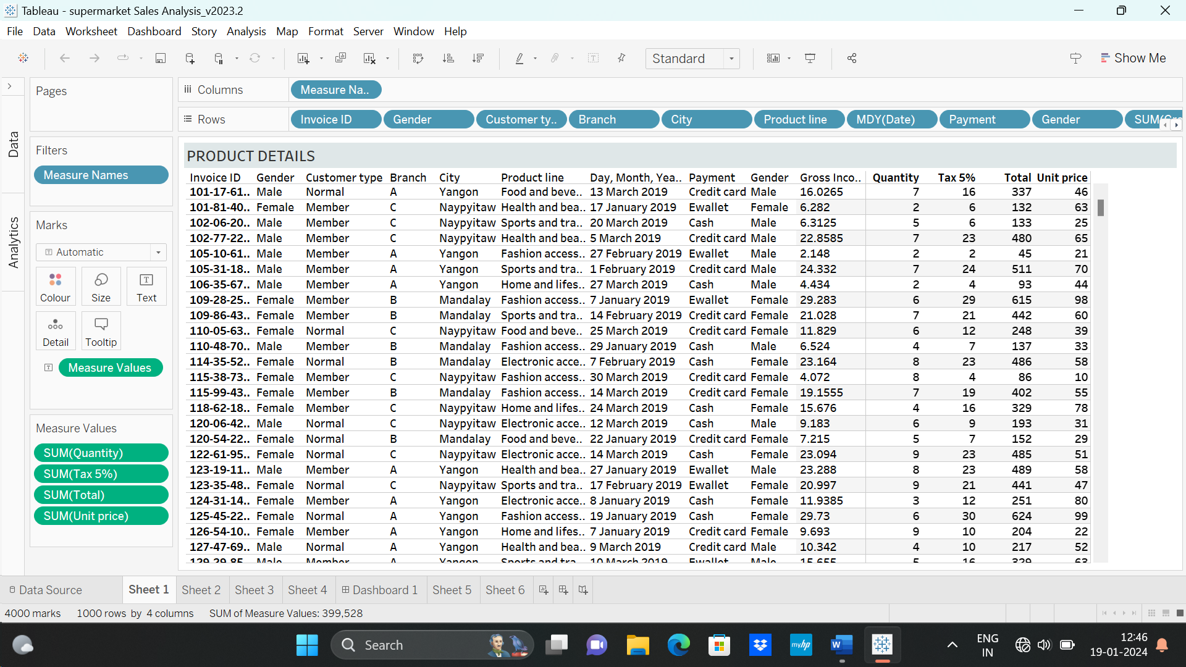

**Sheet 2**

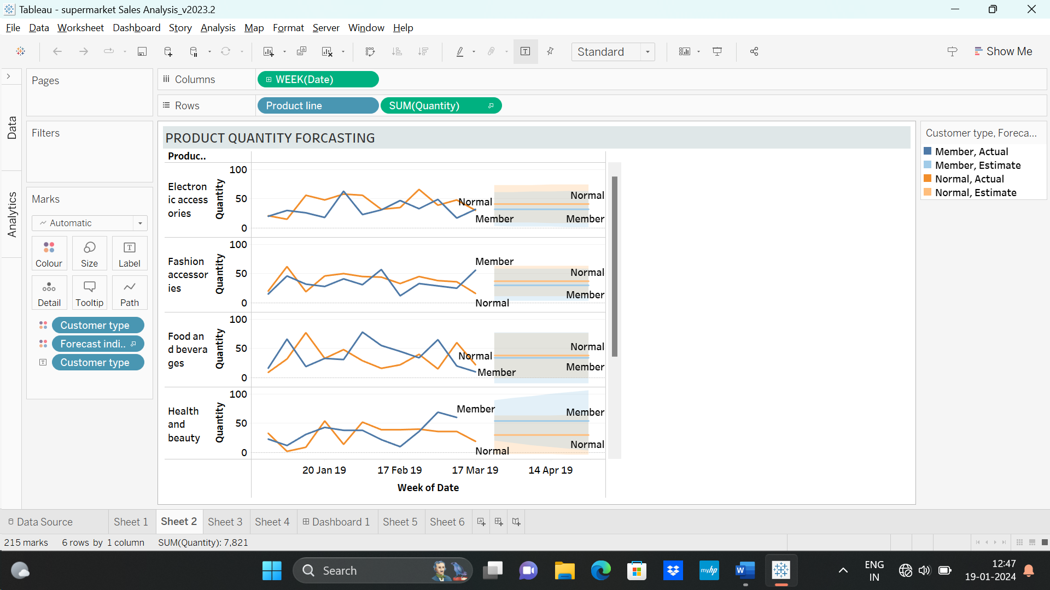

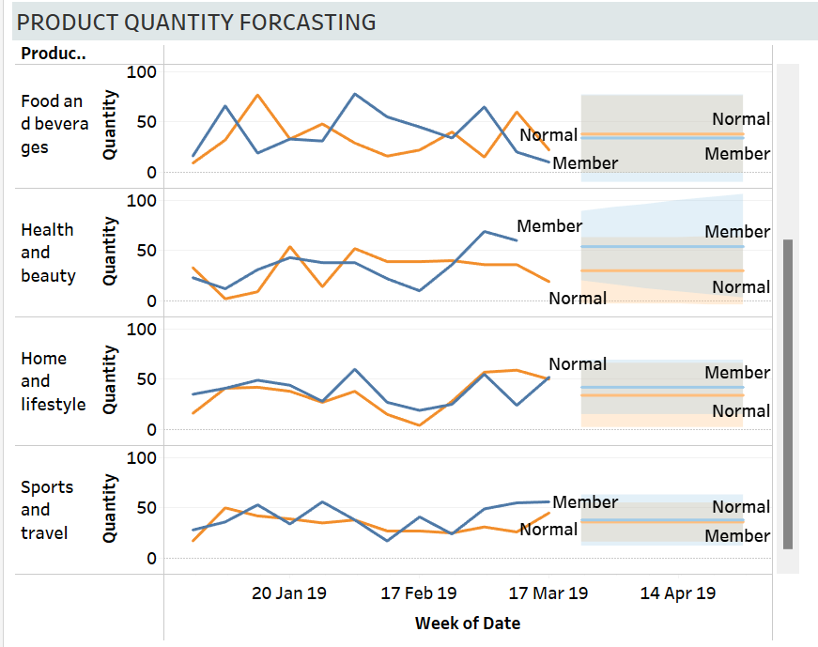

**Sheet 3**

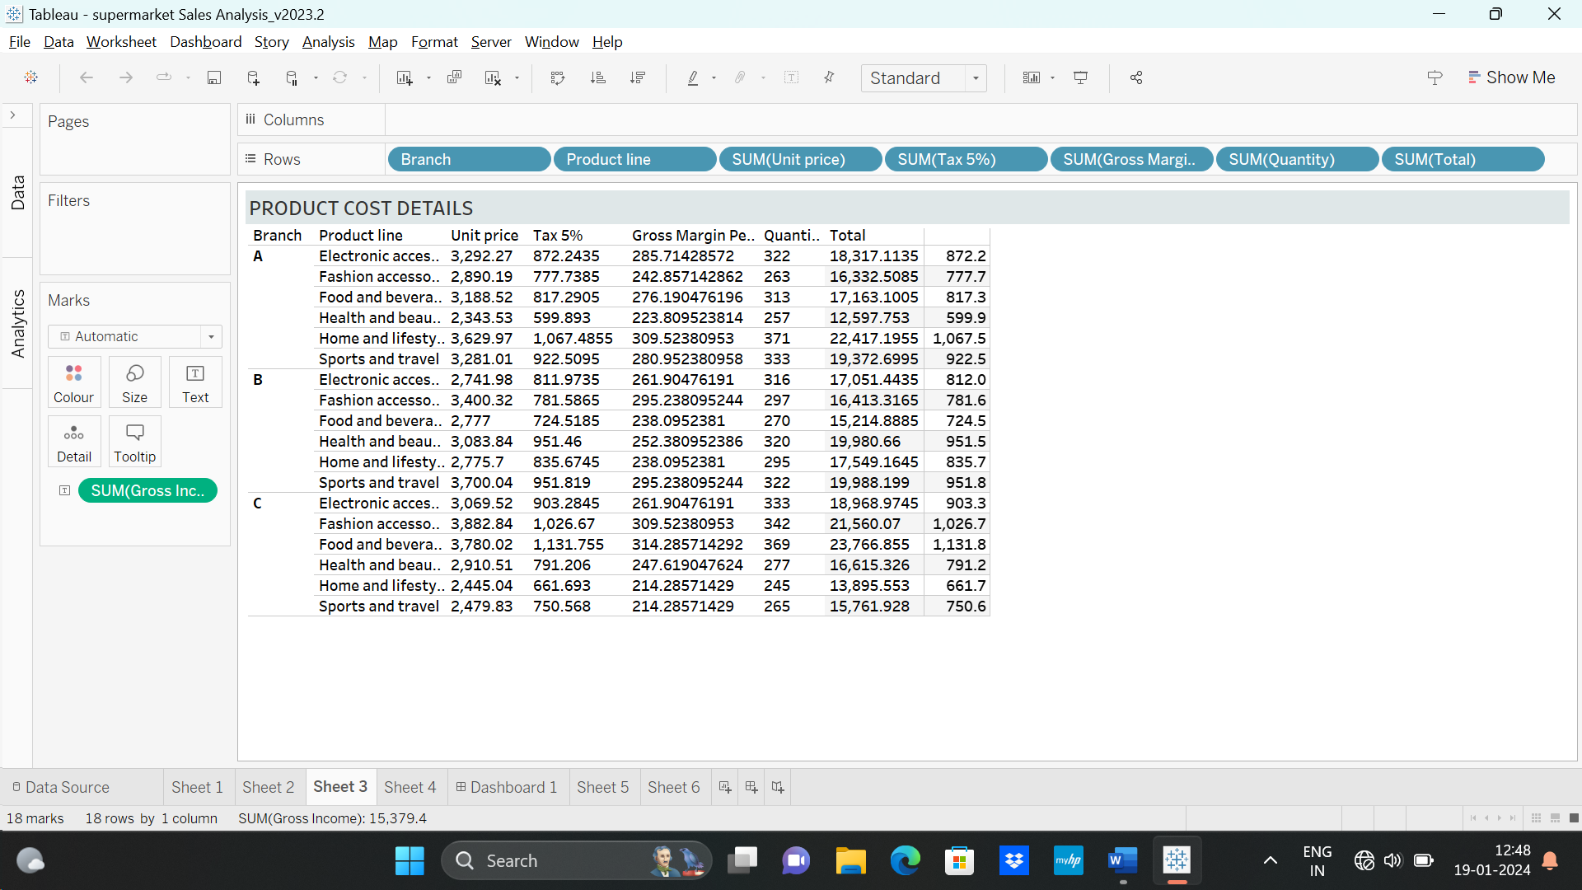

**Sheet 4**

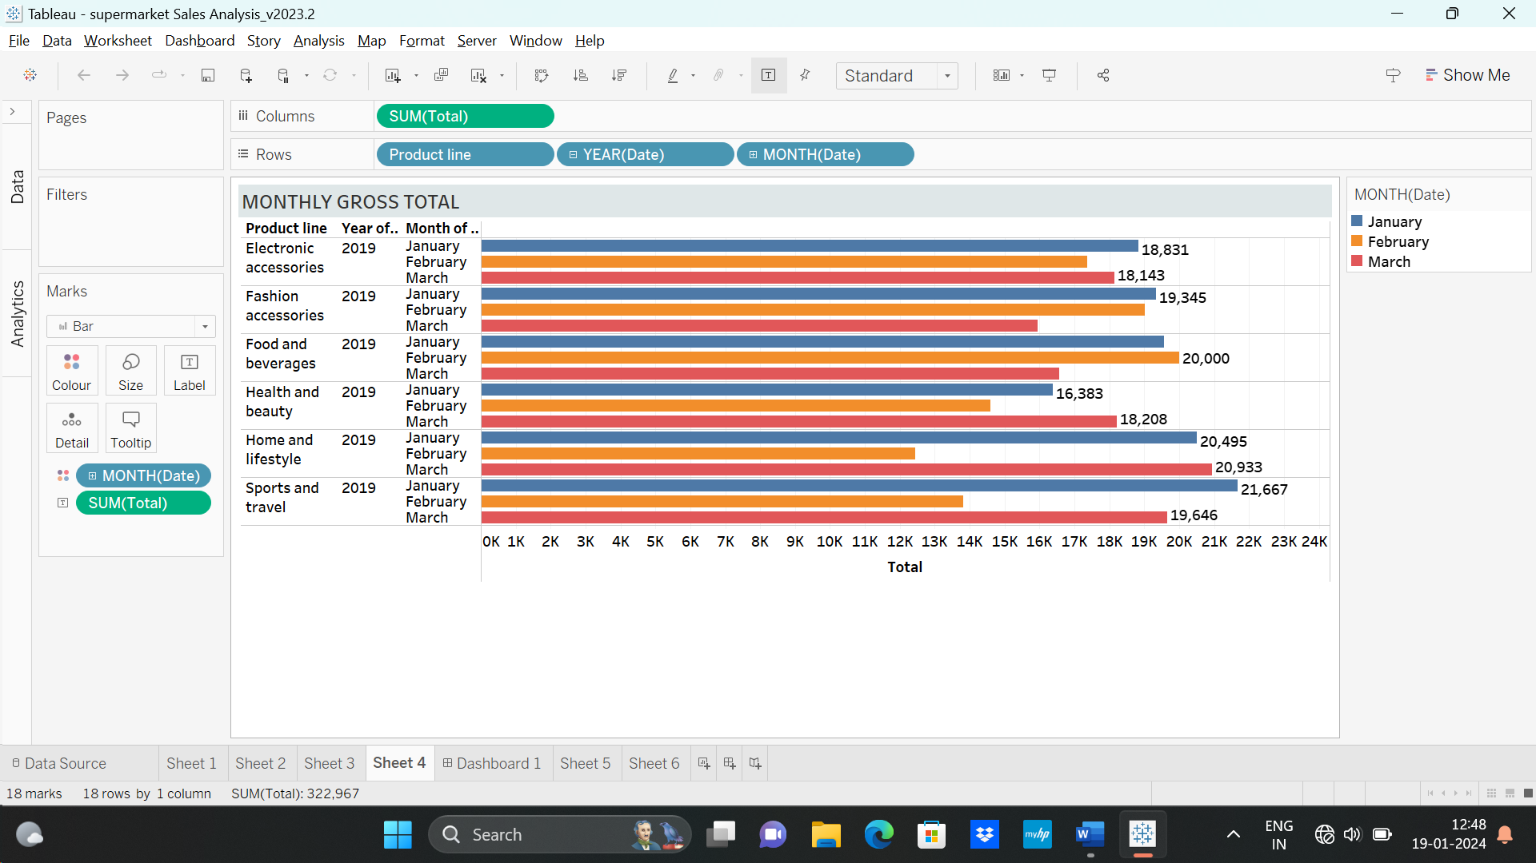

**Dashboard**

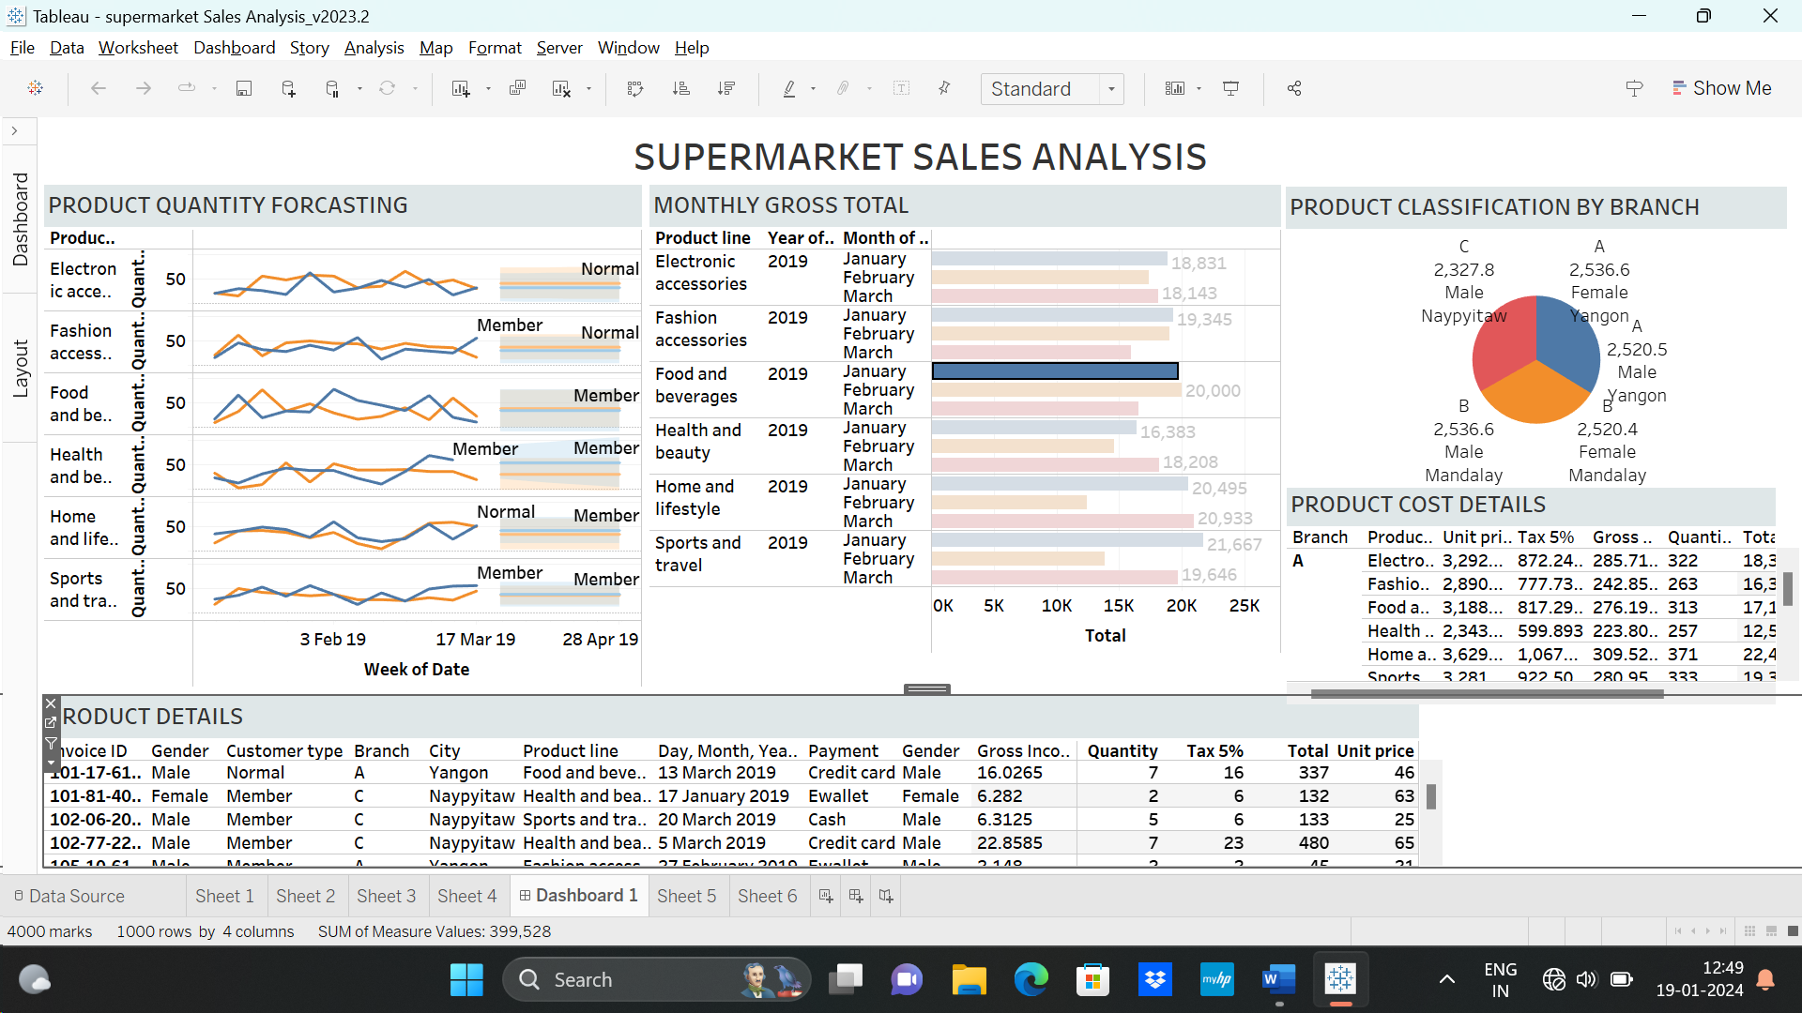

**Discussion of Key Findings and Insights:**

The analysis of the supermarket sales data has yielded valuable insights that provide a comprehensive understanding of various aspects of the business. In this section, we delve into the key findings and their implications:

**Sales Performance:**

Total Sales Trends: The examination of total sales over the previous year reveals a consistent upward trajectory, with notable spikes during holiday seasons and promotional events.

Monthly Patterns: Monthly trends indicate increased sales during specific months, suggesting seasonality influences consumer behavior. This insight can guide inventory management and marketing strategies.

Product-wise Contribution: Certain product categories consistently contribute significantly to overall revenue, emphasizing the importance of optimizing stock levels for these items.

**Customer Behavior:**

Customer Segmentation: Through clustering analysis, customers were categorized into distinct segments based on purchasing behavior. This has unveiled patterns, such as the existence of a loyal customer segment and another segment influenced by promotions.

Customer Loyalty: The analysis shows a high retention rate among a particular customer segment, suggesting the effectiveness of loyalty programs or personalized incentives.

Purchase Patterns: Insights into purchase frequency and volume provide a basis for tailoring marketing efforts to different customer segments.

**Inventory Management:**

Optimal Stock Levels: The evaluation of stock levels indicates areas where adjustments can be made to ensure optimal stock levels, reducing instances of stockouts and excess inventory.

Stockouts and Excess Inventory Impact: Occurrences of stockouts were found to correlate with missed sales opportunities, while excess inventory impacted storage costs. This emphasizes the need for a balanced approach to inventory management.

**Promotional Effectiveness:**

Promotion Impact: The analysis of promotional campaigns indicates varying degrees of impact on sales. Certain promotions were highly successful in driving customer engagement, while others had a limited effect.

**Optimal Promotion Timing:** Insights into optimal promotion timing reveal specific periods during which promotions are more likely to resonate with customers, maximizing their impact on sales.

**Seasonal Analysis:**

Seasonal Sales Patterns: Seasonal analysis uncovered distinct sales patterns influenced by different seasons. This information is crucial for adjusting inventory levels and tailoring marketing strategies to align with seasonal consumer preferences.

Weather Impact: The correlation between weather conditions and purchasing behavior highlights the importance of considering external factors in sales forecasting and inventory planning.

**Geographic Analysis:**

Store-wise Performance: Variations in sales performance among different supermarket branches suggest the need for individualized strategies based on location and customer demographics.

Regional Variances: Regional differences in customer preferences and response to promotions underscore the importance of localized marketing campaigns.

**Machine Learning Model Insights:**

**Regression Analysis:**

The regression model accurately predicts future sales, providing a reliable tool for sales forecasting and inventory planning.

**Customer Segmentation Models:**

Insights from customer segmentation models allow for targeted marketing strategies, enhancing customer engagement and satisfaction.

**Classification Models:**

The classification models effectively predict the success of promotional campaigns, guiding the selection of impactful promotional strategies.

**Integration of Python and Tableau Visualizations:**

**Comprehensive Insights:** The combination of visualizations from Python libraries and Tableau provides a holistic view of the data, allowing for in-depth exploration and analysis.

Interactivity in Tableau: Tableau's interactive dashboards enable stakeholders to dynamically engage with the data, facilitating a deeper understanding of trends and patterns.

Implications for Business Strategy:

**Operational Efficiency:** Insights from the analysis can guide operational improvements, such as optimizing inventory levels, refining promotional strategies, and enhancing store-specific approaches.

**Customer-Centric Approaches:** Understanding customer behavior allows for the implementation of personalized services, loyalty programs, and targeted marketing efforts, fostering a customer-centric approach.

**Strategic Decision-Making:** The findings provide a data-driven foundation for strategic decision-making, enabling the supermarket to proactively respond to market dynamics and enhance overall business performance.

**Recommendations for Action:**

Refine Inventory Management: Implement strategies to minimize stockouts and reduce excess inventory, optimizing stock levels based on sales patterns and seasonal variations.

**Targeted Marketing:** Tailor marketing campaigns based on customer segmentation, leveraging insights into preferences, and purchasing behavior.

Optimize Promotional Strategies: Align promotions with peak sales periods and customer preferences, focusing on campaigns with proven effectiveness.

**Localization Strategies:** Implement localized strategies for different supermarket branches, considering regional variances in customer behavior.

**Continuous Monitoring:** Establish a system for continuous monitoring of key performance indicators, allowing for real-time adjustments and responsiveness to changing market conditions.

Future Considerations:

**Integration of Real-Time**

**Data:** Explore opportunities to integrate real-time data into the analysis for more dynamic insights.

Advanced Analytics Techniques: Investigate advanced analytics techniques, such as machine learning algorithms for anomaly detection or predictive maintenance, to further refine decision-making processes.

**Customer Feedback Analysis:** Incorporate customer feedback data for a more holistic understanding of customer satisfaction and preferences.

In conclusion, the supermarket sales analysis has unearthed actionable insights that can drive strategic decision-making and operational improvements. The integration of Python libraries and Tableau visualizations has provided a comprehensive and interactive platform for exploring and communicating these findings. As the supermarket moves forward, leveraging these insights will be crucial in adapting to market dynamics, enhancing customer satisfaction, and maintaining a competitive edge in the retail landscape.

**Limitations and future scope:**

Despite the valuable insights gained from the supermarket sales analysis, it's essential to acknowledge certain limitations that may impact the interpretation and generalizability of the findings:

**Data Quality:**The accuracy and reliability of the analysis heavily depend on the quality of the data. Incomplete or inaccurate data, such as missing entries or errors in transaction logs, could introduce biases or inaccuracies.

**Assumption of Stationarity:**The analysis assumes that sales patterns and customer behavior remain relatively stationary over time. Any significant shifts in market trends or consumer preferences may not be fully captured in the historical data.

**External Factors:**While efforts were made to consider external factors such as weather conditions, macroeconomic trends, and local events, certain unforeseen external influences may not have been accounted for, impacting the accuracy of predictions.

**Model Complexity:**The chosen machine learning models, while effective for the current analysis, might not capture all nuances in the data. More sophisticated models or ensemble techniques could be explored for improved accuracy.

**Data Privacy and Security:**If the dataset contains sensitive customer information, privacy and security concerns need to be addressed. Anonymization and data encryption should be considered to protect customer privacy.

**Lack of Causation Inference:**While correlations between variables were identified, establishing causation requires additional experimentation or in-depth domain knowledge. The analysis may provide insights into associations, but causative relationships may not be definitive.

Building on the current analysis, there are several avenues for future exploration and enhancement of the supermarket sales analysis project:

**Real-Time Data Integration:**Implement systems to integrate real-time data streams, allowing for continuous monitoring and immediate responses to changing market conditions.

**Advanced Analytics Techniques:**Explore advanced analytics techniques, such as predictive maintenance models for equipment, sentiment analysis for customer feedback, and more sophisticated machine learning algorithms for customer segmentation.

**Dynamic Pricing Strategies:**

Incorporate dynamic pricing strategies based on real-time demand, competitor pricing, and other market factors to maximize revenue and maintain competitiveness.

**Enhanced Customer Feedback Analysis:**

Integrate more comprehensive customer feedback analysis, including sentiment analysis and qualitative data, to gain deeper insights into customer satisfaction and preferences.

**Cross-Channel Analytics:**Expand the analysis to include cross-channel analytics, integrating online and offline sales data to gain insights into omnichannel customer behavior.

By addressing these future considerations, the supermarket can further enhance its data-driven decision-making capabilities, stay adaptive to market changes, and continuously optimize its operations for sustained success in the retail landscape.

**Conclusion:**

The adoption of machine learning techniques in sales forecasting and inventory management can help improve accuracy and efficiency in supermarkets. However, it is important to ensure that the machine learning models are continually monitored and evaluated to ensure their effectiveness over time. Future research in this area should focus on further investigation of the effectiveness of different machine learning algorithms and data sources in sales forecasting, analysis of the impact of different marketing strategies on sales, and examination of the ethical considerations associated with the collection and analysis of customer data.

In conclusion, the Supermarket Sales Analysis project has successfully utilized data analytics and machine learning to extract actionable insights. The integration of Python libraries and Tableau provided a comprehensive approach to data visualization, allowing stakeholders to interact with and derive value from the analysis. The machine learning models, validated through rigorous training and evaluation, contribute to informed decision-making in various aspects of supermarket operations. Sales forecasting models enhance inventory management, customer segmentation guides targeted marketing initiatives, and promotional impact models optimize the allocation of resources.While the project has provided valuable insights, it's crucial to acknowledge its limitations. Future work could involve incorporating additional external datasets for a more holistic analysis and exploring advanced machine learning models to further refine predictive capabilities.

The Supermarket Sales Analysis project serves as a foundation for ongoing improvements and strategic decision-making within the supermarket industry. By harnessing the power of data analytics, supermarkets can navigate the complexities of the market, enhance customer satisfaction, and ultimately drive sustained success.

References:

* Danyel Fisher, Rob DeLine, Mary Czerwinski, and Steven Drucker. 2012. Interactions with big data analytics. interactions 19, 3 (May + June 2012), 50–59. https://doi.org/10.1145/2168931.2168943
* R. Navodya Gurusinghe, Bhadra J. H. Arachchige, Dushar Dayarathna. (2021) Predictive HR analytics and talent management: a conceptual framework. Journal of Management Analytics 8:2, pages 195-22